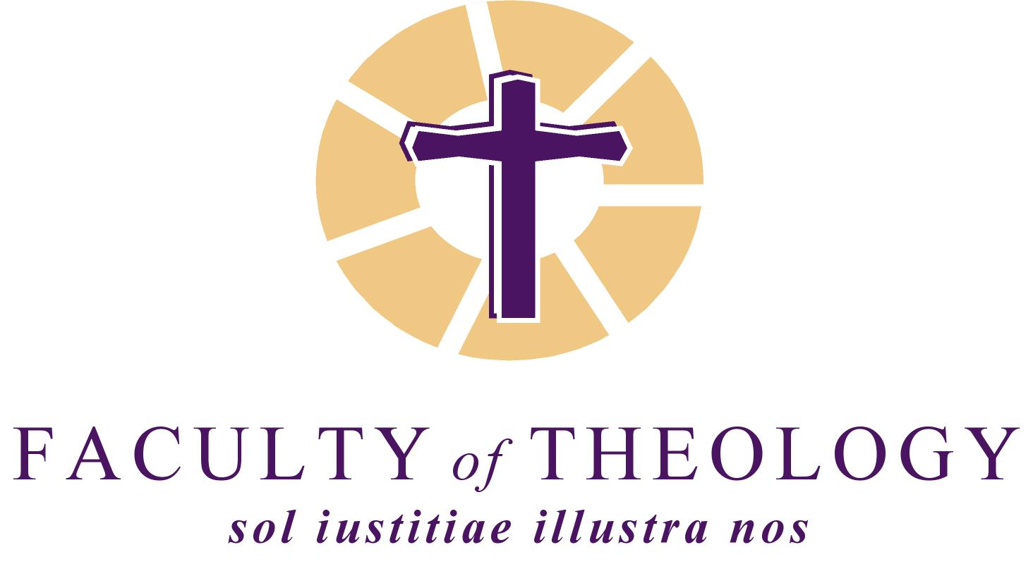

CONFERENCE
Theology on the Edge:
Honouring John de Gruchy on his 75th birthday

3-5 September 2014, Stellenbosch
Attie van Wijk Auditorium, Faculty of Theology

PROGRAMME

WEDNESDAY 3 SEPTEMBER 2014

8h00: Registration

9h00: Opening
Robert Vosloo

9h10: Word of welcome
Prof Nico Koopman, Dean, Faculty of Theology

Session 1: Engaging Dietrich Bonhoeffer [Chair: Robert Vosloo]

9h20: Dietrich Bonhoeffer – Christian existence on the edge of the future
Wolfgang Huber

10h00: Bonhoeffer and the Future of Public Theology in South Africa
Nico Koopman

10h40: Tea

11h10: Panel Discussion
Clifford Green, Michael Phiri, Karola Radler, Frits de Lange

12h40: Lunch
Book launch: John de Gruchy, A Theological Odyssey: My Life in Writing (Sun Media)
Chair: Len Hansen
Speakers: Keith Clements, Roderick Hewitt, Cas Wepener

Session 2: Theological Aesthetics [Chair: Lyn Holness]

14h00: Sanctification: Towards a Pedagogy of Affect
Graham Ward

14h40: The Aesthetics of Forgiveness: Representing Forgiveness Artistically
Frank Burch Brown

15h20: Tea

15h50: Panel Discussion
Janet Trisk, Marnus Havenga, Awet Andemicael, Johan Cilliers

18h30: Welcoming function: Cafeteria, Faculty of Theology

19h15: Concert: Libertas Choir

THURSDAY 4 SEPTEMBER 2014

9h00: Opening
Robert Steiner

Session 3: Christian Humanism [Chair: Elna Mouton]

9h10: The Mystery of Hope: a Response to the Tragic
Denise Ackermann

9h50: The Spirit of Humanity: Contra Theologies of Death
Jim Cochrane

10h30: Tea

11h00: Panel Discussion
Karin Sporre, Martin Prozesky, Nadia Marais, Simangaliso Kumalo

12h30: Lunch
Book Launch: Denise Ackermann, Surprised by the Man on the Borrowed Donkey: Ordinary Blessings (Lux Verbi)
Speaker: Dirkie Smit

Session 4: Theology and Science [Chair: Dion Forster]

14h00: Iain McGilchrist

14h40: The Emergence of Personhood: Why the Evolution of the Moral Sense and Symbolic Behavior defines the Human Self
J. Wentzel van Huyssteen

15h20: Tea

15h50: Panel Discussion
Ernst Conradie, Gys Loubser, Larry Rasmussen, Rika Preiser

18h15: Evening reception: Clos Malverne wine estate

FRIDAY 5 SEPTEMBER 2014

9h00: Opening
Bruce Theron

Session 5: The Struggle Continues [Chair: Edwin Arrison]

9h10: Economic Freedom
Serene Jones

9h50: 'A Hope Unprepared to Accept Things as They Are': Reflections on John De Gruchy's Challenges for a Theology at the Edge
Allan Boesak

10h30: Tea

11h00: Panel Discussion
Rothney Tshaka, Christo Lombard, Helené van Tonder, Deon Snyman

12h30: Conclusion
John de Gruchy

